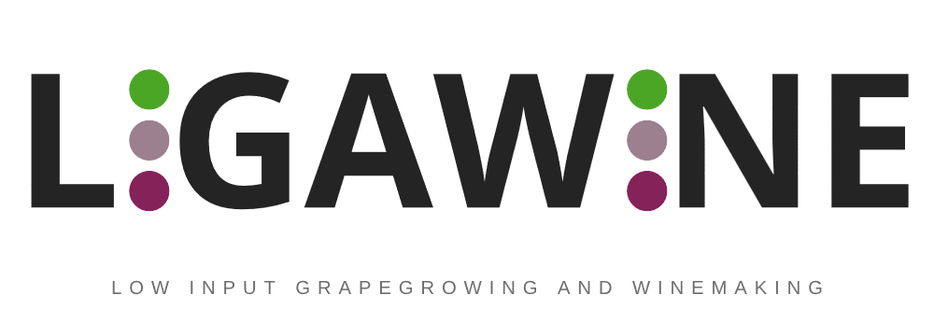

Low Input Grapegrowing and Winemaking

OPEN CALL – Declaration of Honour

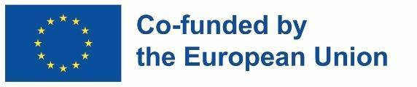
Funded by the European Union. Views and opinions expressed are however those of the author(s) only and do not necessarily reflect those of the European Union or EISMEA. Neither the European Union nor the granting authority can be held responsible for them.

Declaration of Honour
For Strand 1: Mini-Consortia, this Declaration of Honour must be completed and signed by each Consortium member. For Strand 2: Open Challenges, it must be completed and signed by the single applicant.

By signing this document, I declare that:
- I am authorised to legally bind the legal entity named below, to the conditions stated in this form.
- I and the business entity that I legally represent are fully aware and duly accept all rules and conditions as expressed in the documents and annexes related to the LIGAWINE Open Call and will fully respect any evaluation decision and application selection made under the LIGAWINE Open Call.
- All information provided in this declaration is true and legally binding.
Applying Business Entity Legal Representative Contact Information:
Title (Mr., Mrs., Dr.)
Name
Surname
Business entity
Position in the entity
Full address
Country
Email address
(Mobile) Telephone

Signature and stamp (if applicable):

Declaration of Honour on exclusion criteria and absence of conflict of interest
By signing this declaration of honour, I declare that all the information provided below is true and legally binding both for me and for the business entity that I legally represent:
      - I declare that the business entity mentioned is not in one of the following situations:
- it is bankrupt or being wound up, is having its affairs administered by the courts, has entered into an arrangement with creditors, has suspended business activities, is the subject of proceedings concerning those matters, or is in any analogous situation arising from a similar procedure provided for in national legislation or regulations;
- it or persons having powers of representation, decision making or control over it have been convicted of an offence concerning their professional conduct by a judgement which has the force of res judicata;
- it has been guilty of grave professional misconduct proven by any means which the contracting authority can justify including by decisions of the European Investment Bank and international organisations;
- it is not in compliance with its obligations relating to the payment of social security contributions or the payment of taxes in accordance with the legal provisions of the country in which it is established or with those of the country of the contracting authority or those of the country where the contract is to be performed, to be proved by the deliverance of official documents issued by the local authorities, according to the local applicable rules;
- it or persons having powers of representation, decision making or control over it have been the subject of a judgement which has the force of res judicata for fraud, corruption, involvement in a criminal organisation or any other illegal activity, where such illegal activity is detrimental to the Union’s financial interests;
- is subject to an administrative penalty for being guilty of misrepresenting the information required by the contracting authority as a condition of participation in a grant award procedure or another procurement procedure or failing to supply this information or having been declared to be in serious breach of its obligations under contracts or grants covered by the Union's budget.
- I declare that the natural persons with power of representation, decision-making or control over the above-mentioned business entity are not in the situations referred to in a) to f) above;
- I declare that:
- To the best of my knowledge, neither the applicant legal entity nor any person with powers of representation, decision-making, or control over it is in a situation of actual, potential, or perceived conflict of interest in relation to the LIGAWINE Open Call, the LIGAWINE Consortium, the Open Call management team, or the evaluation process.
- I have not made false declarations in supplying the information required by participation in the Open Call of LIGAWINE Project or have failed to supply the information required;
- I am not in one of the situations of exclusion, referred to in the abovementioned sub-points a) to f) within point 1.
- I declare that the applicant legal entity is legally established in a country eligible for participation and funding under the Interregional Innovation Investments Instrument (I3) and the applicable rules of the LIGAWINE Grant Agreement.
- I am aware of and fully accept all LIGAWINE Open Call conditions and rules as expressed in the Open Call Kit, including the Applicants’ Guide, Proposal Template, Budget Template, Consortium Declaration where applicable, SME Declaration, Bank Account Information Form where applicable, and the Indicative Sub-grant Agreement.
- I certify that the business entity that I represent:
- is committed to participating in the LIGAWINE Open Call sub-project, should my application get selected for funding;
- has stable and sufficient sources of funding to maintain its activity throughout its participation in the LIGAWINE Open Call sub-project and to provide any additional resources necessary for implementation that are not covered by the LIGAWINE financial support;
- has or will have the necessary resources as and when needed to carry out its involvement in the LIGAWINE Open Call sub-project.
- I confirm that all proposed services, including the means of their delivery and upkeep, have been reviewed to ensure compliance with all relevant legislation on data protection, privacy, and fundamental rights.
- I declare that the activities and costs proposed for funding under the LIGAWINE Open Call are not receiving and will not receive double funding from the European Union budget or any other public funding source. I undertake not to request or receive other EU or public funding for the same activities or costs covered by the LIGAWINE sub-project.
- I declare that the applicant legal entity is not a LIGAWINE consortium partner, is not an affiliated entity of a LIGAWINE consortium partner, as elaborated within Annex 3, and is not involved in the management, evaluation, or implementation of the Open Call in a way that creates a conflict of interest.
Full name:  ________________________________________  On behalf of Business entity:  ________________________________________ | Signature and stamp (if applicable):
Done at (place) ____________________________ the day (dd) _______ month (mm) _______ year (yyyy)

