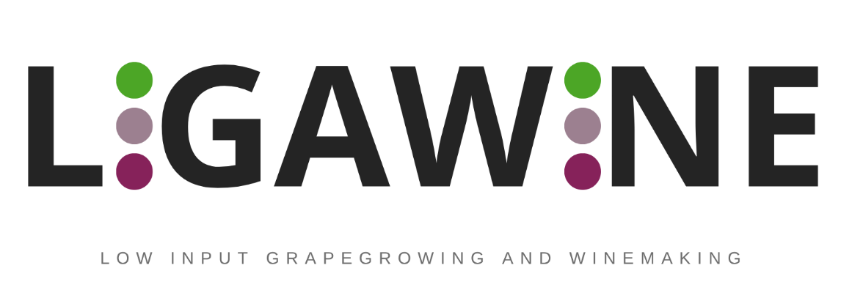

Low Input Grapegrowing and Winemaking

OPEN CALL – Consortium Declaration

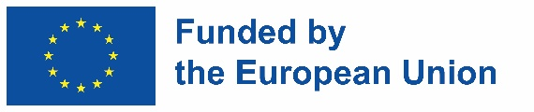
Funded by the European Union. Views and opinions expressed are however those of the author(s) only and do not necessarily reflect those of the European Union or EISMEA. Neither the European Union nor the granting authority can be held responsible for them.

Title of the proposal: ___________________________________________________
On behalf of _____________________________ (Company name) established in ______________________________, (Official address), VAT/TAX number_________________, represented for the purposes of signing and submitting the Declaration by ___________________________ (Name of legal representative), declares that all provided information below is true and legally binding.

The Consortium leader declares that all Consortium partners have agreed on their roles and budget shares.
Payments will be done separately to each partner directly from the Consortium coordinator.
The LIGAWINE project bears no responsibility in case the Consortium leader violates the mutual agreement set in this Consortium Declaration.
The LIGAWINE project bears no responsibility in case of dispute among Consortium partners regarding IP rights and allocation of income generated through reward crowdfunding campaigns.
By submitting this document, the Consortium accepts all the terms and the rules explained in LIGAWINE Open Call kit.
Consortium Leader

Full name

Full address

Legal representative

Legal representative signature and stamp (if applicable)

Project Partner 1

Full name

Full address

Legal representative

Legal representative signature and stamp (if applicable)

